#
# 20171024
# To connect from local network.
#
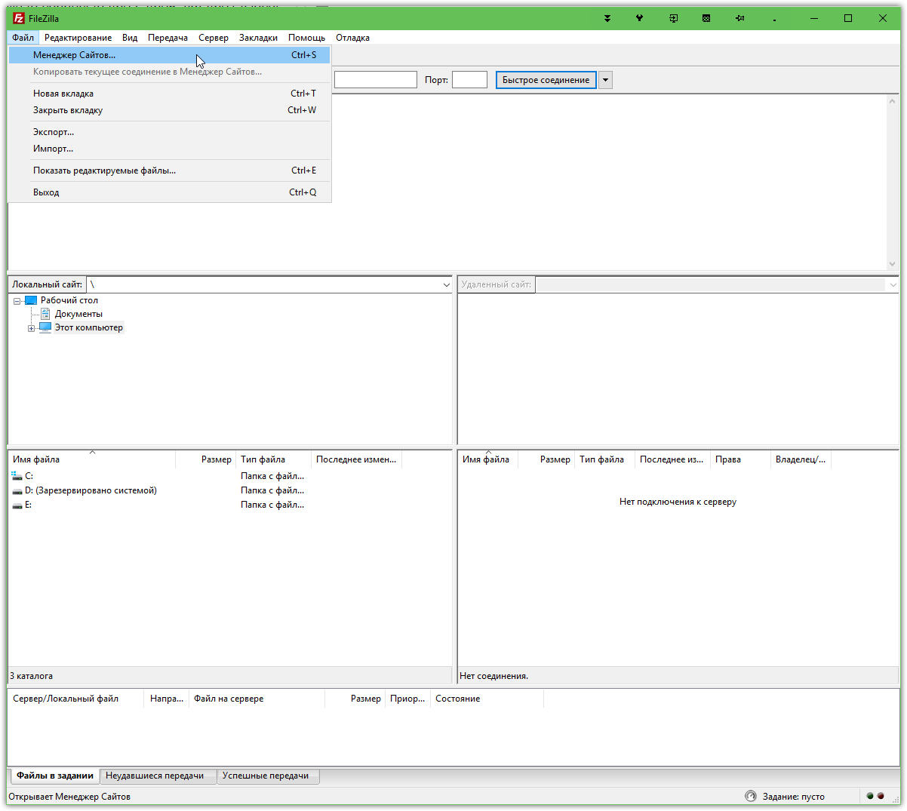

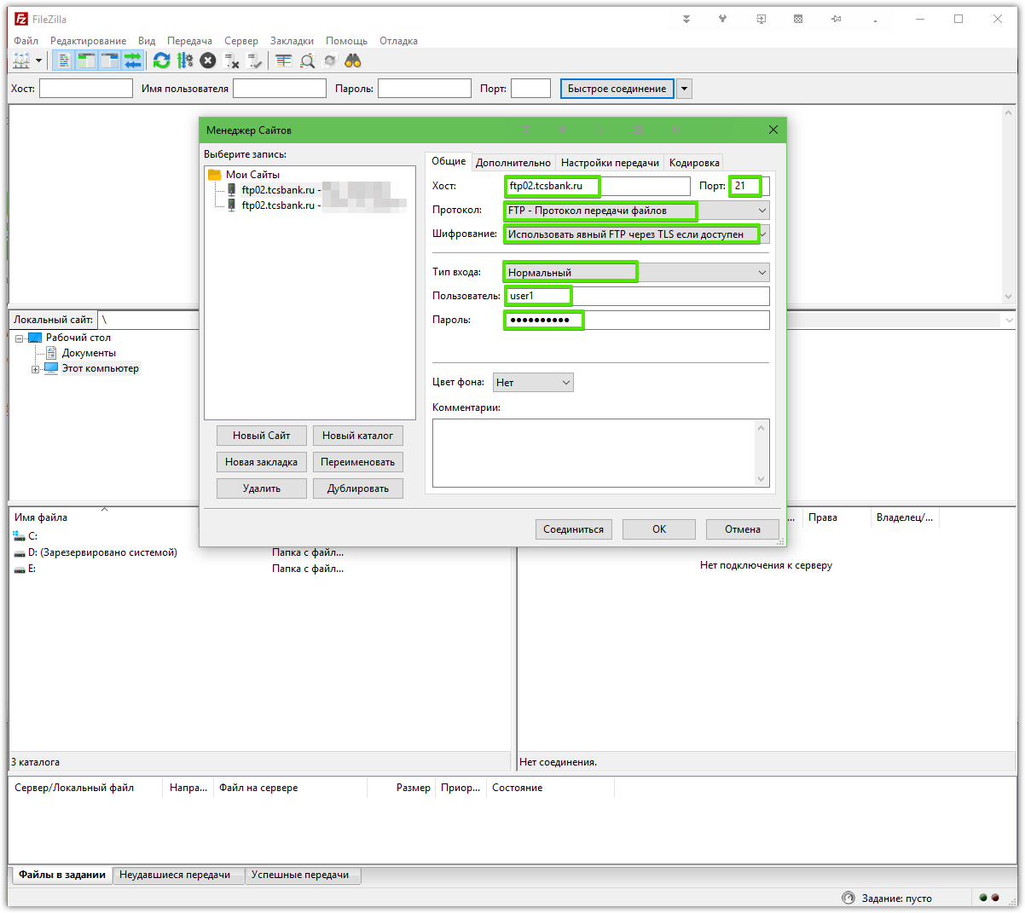

20160322

https://wiki.tcsbank.ru/pages/viewpage.action?pageId=42077242

Пример подключения к FTP с помощью FileZilla
- Перейти в Менеджер Сайтов (Файл –> Менеджер Сайтов)
- Добавить новый сайт, указать следующие параметры:
- Хост: ftp05.tinkoff.ru (если подключаться из внутренней сети Банка – vm-ftp05.tcsbank.ru)
- Протокол: FTP
- Шифрование: Требовать FTP через TLS (явный)
- Тип входа: Нормальный
- Имя пользователя и пароль в соотв. с учетными данными
- 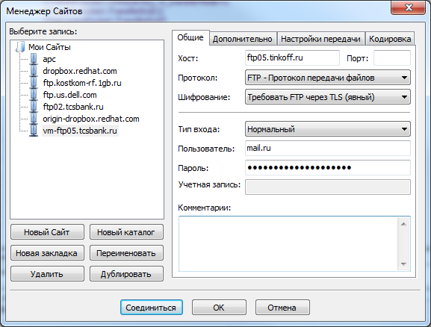
- Нажать кнопку «Соединиться», при запросе подтверждения сертификата – нажать ОК

https://www.digitalocean.com/community/tutorials/how-to-configure-vsftpd-to-use-ssl-tls-on-a-centos-vps

How To Connect to the vsftpd Server with FileZilla
SSL and TLS connections are possible with most modern FTP clients. We will show you how to set up FileZilla to use secured connections due to its cross-platform compatibility. We will assume that you have already installed the client using whatever the appropriate installation procedures are for your computer.
Open the FileZilla program. In the interface, you can click on an icon to open "Site Manager". It should look like the icon on the far left in this picture:
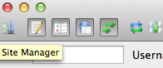
In the new interface that pops up, you should click on the "New Site" button in the lower left corner. Name the server connection so that you can easily identify it later
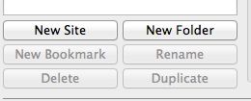
Fill in the IP address in the "Host" field and select "FTP - File Transfer Protocol" from the Protocol drop-down menu. For the Encryption drop-down, choose "Require explicit FTP over TLS".
Select "Ask for password" from the Login Type menu. Fill in the FTP user we created for the "User" field:
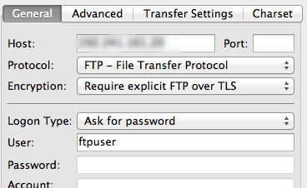
Now, you can click "Connect" at the bottom of the panel. You will be prompted to enter the password for your FTP user:
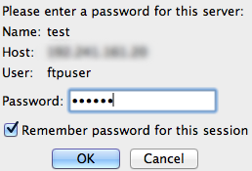
The next step is the first sign that we are connecting with TLS to our remote server. We will be asked to accept the certificate that is being used.
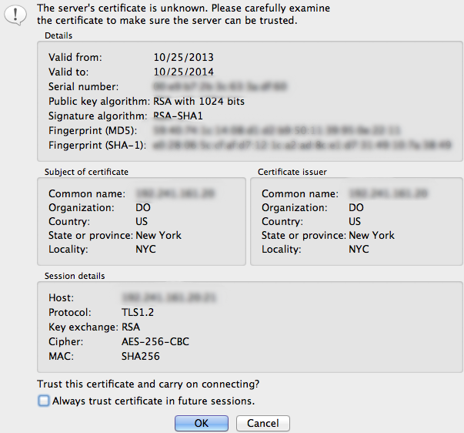
You should be able to see the information you filled out when you created the certificate in order to verify that you're actually connecting to the correct place.
Accept the certificate to establish the connection.

